EXPERIMENT 8
CONFIGURING USER MANAGEMENT AND ROLE-BASED ACCESS CONTROL (RBAC) IN ZOHO CREATOR
Gym Membership Enrollment & Front Desk Management

Parikshith P
Reg. No: 2116241401062
Computer Science and Business Systems
Rajalakshmi Engineering College, Chennai

Aim
To configure user permissions, roles, and data-sharing rules in Zoho Creator for the Gym Membership Enrollment & Front Desk Management application.

Software Requirements
- Zoho Creator
- Web browser
- Internet connection

Description
Role-Based Access Control (RBAC) is a security mechanism that assigns permissions to users according to their roles. It helps control who can access application components and membership records.
Zoho Creator provides user permission profiles, roles, and data-sharing rules to manage access to application data. Permission profiles define the operations users can perform, roles represent organizational responsibilities, and data-sharing rules determine how records are shared between roles or users.
In this experiment, the existing Read and Write permission profiles were examined, the CEO role was reviewed, a Gym_Manager role was created, and a read-only data-sharing rule was configured for the membership enrollment form.

Procedure

Step 1: Open User Permissions
- Open the Gym Membership Enrollment & Front Desk Management application.
- Navigate to Settings.
- Select User Permissions under the Permissions section.
- Observe the available permission profiles.
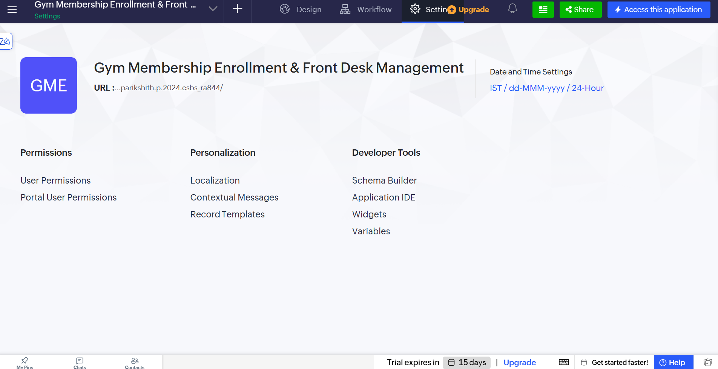
Figure 1. Application Settings page showing the Permissions, Personalization, and Developer Tools sections.
Two existing profiles were available:
- Read: Provides read permission for application components.
- Write: Provides write permission for application components.

These profiles demonstrate how access to application functionality can be controlled.
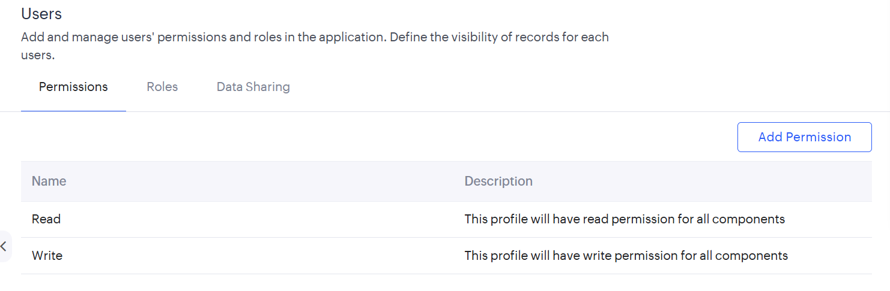
Figure 2. User Permissions page displaying the Read and Write profiles.

Step 2: Examine the Existing Role
- Open the Roles tab.
- Select the existing CEO role.
- Review its role details and associated users.
The CEO role was configured with the following details:
- Role Name: CEO
- Share Data with Peers: No
- Description: Users belonging to this role can access data of other users.

The role configuration was examined to understand how organizational roles and record access are managed in Zoho Creator.
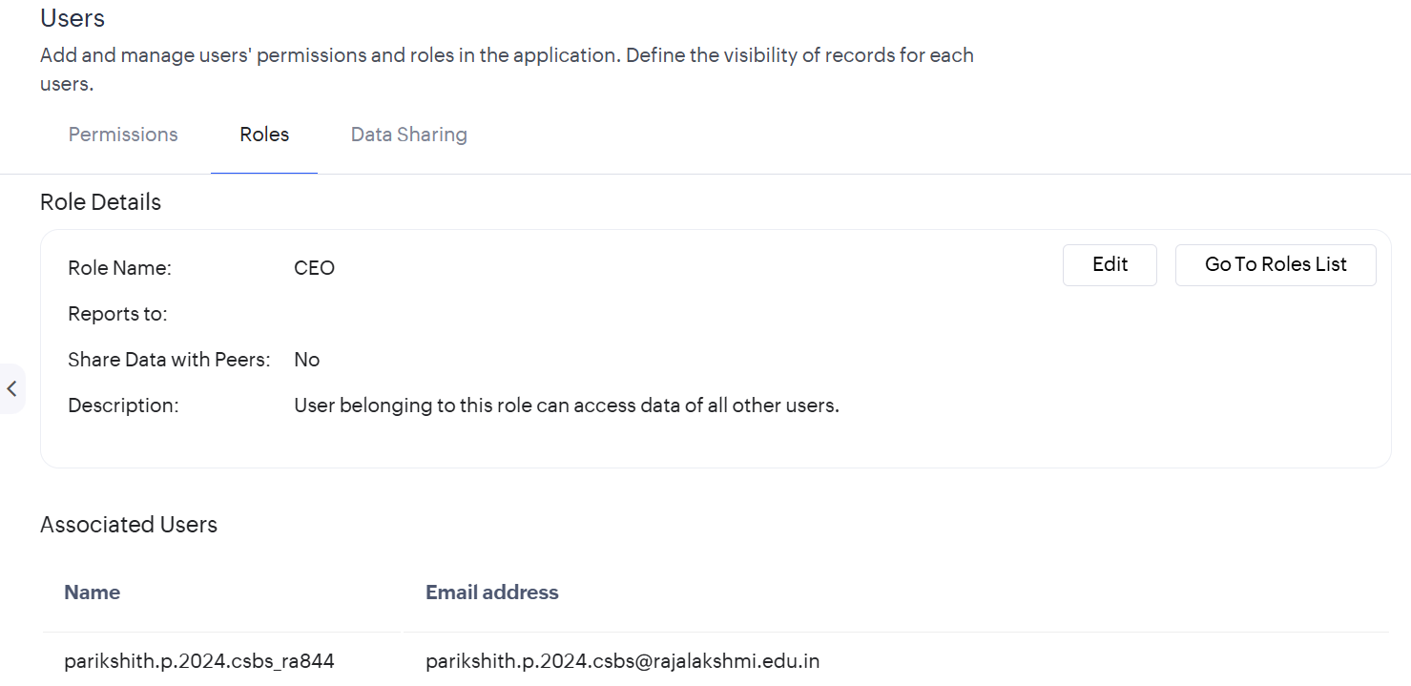
Figure 3. CEO role details page.

Step 3: Create the Gym Manager Role
- Navigate to the roles list.
- Create a new role named Gym_Manager.
- Configure its role hierarchy using the available settings.
- Save the role.
The Gym_Manager role represents the gym manager responsible for viewing membership information.

Step 4: Open Data Sharing
- Navigate to the Data Sharing tab under User Permissions.
- Observe the existing data-sharing configuration.
- Click Add Rule or New Share Rule to create a rule.
Data-sharing rules allow records associated with one role or user to be shared with another role or user.
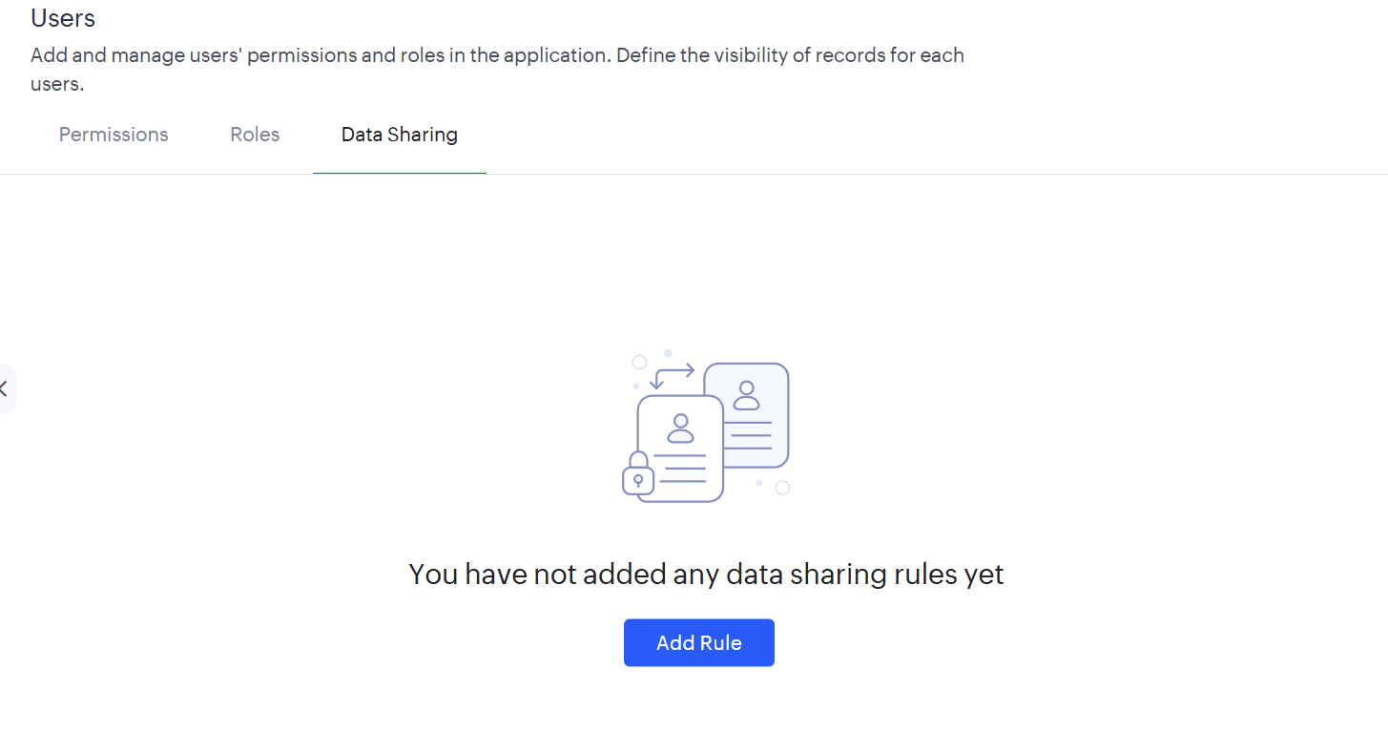
Figure 4. Data Sharing page before adding a rule.

Step 5: Configure the Data-Sharing Rule
Create a new share rule with the following configuration:
Field | Configuration
Name | Gym_Manager_Read_Access
Form | Membership_Enrollment_Form
Records shared from | Roles → CEO
Records shared to | Roles → Gym_Manager
Level of access | Read Only

The rule was saved successfully and appeared in the Data Sharing list.
This configuration specifies read-only sharing of membership records from the CEO role to the Gym_Manager role.
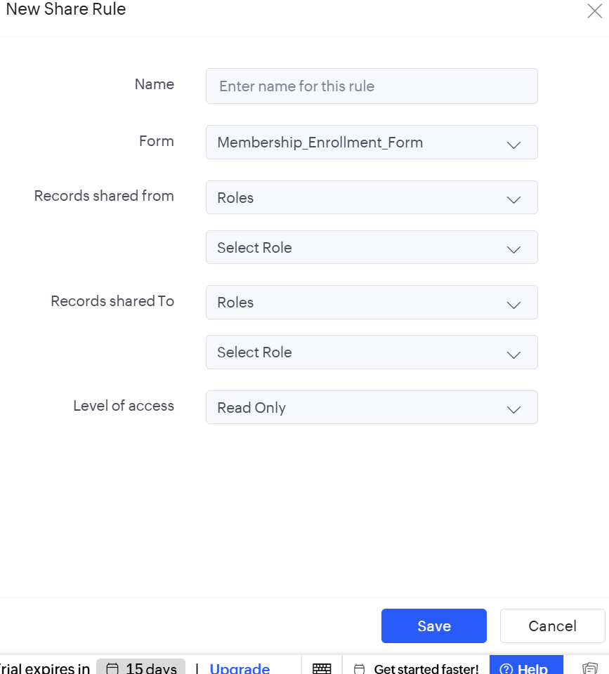
Figure 5. New Share Rule dialog before configuration.
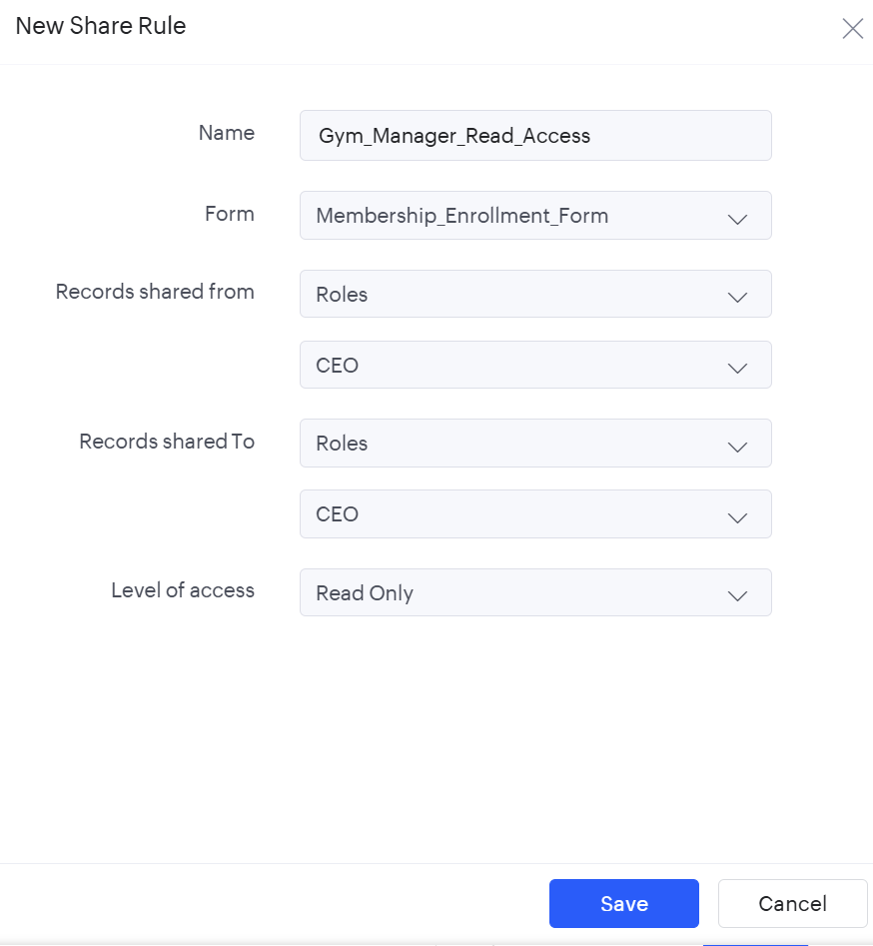
Figure 6. New Share Rule configuration for Gym_Manager_Read_Access.
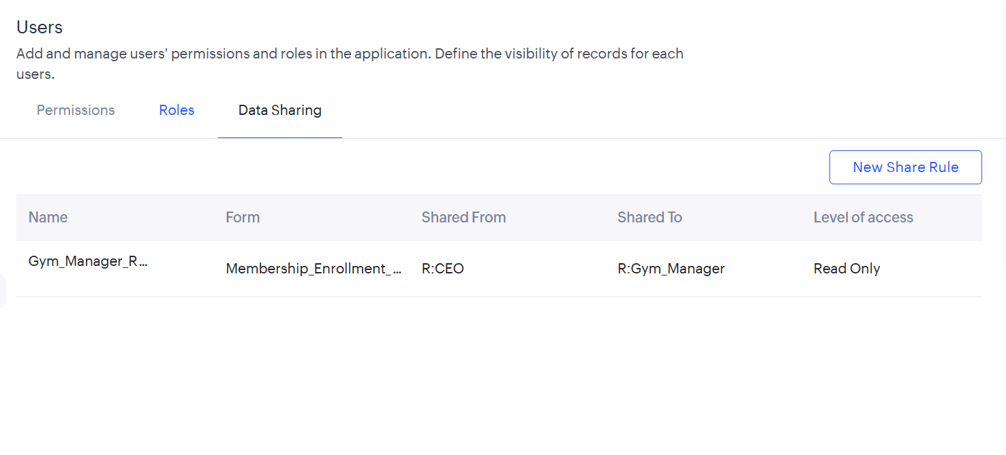
Figure 7. Saved data-sharing rule showing CEO as the source role, Gym_Manager as the destination role, and Read Only as the access level.

Output
The Zoho Creator application was configured with existing Read and Write permission profiles, the CEO role was examined, a Gym_Manager role was created, and a data-sharing rule named Gym_Manager_Read_Access was saved for the membership enrollment form.
The rule specifies read-only access for records shared from CEO to Gym_Manager.

Result
Thus, user management and role-based access control were configured in Zoho Creator. Permission profiles, role configuration, and a read-only data-sharing rule were used to demonstrate access management for the Gym Membership Enrollment & Front Desk Management application.

